step-by-step for installing Docker on your Windows PC, building an image, and pushing it to Docker Hub.

Open PowerShell (as Administrator) and run:
wsl –install
wsl --list –verbose


Step 1: Download Docker Desktop
Go to the official site and download it:
👉 https://www.docker.com/products/docker-desktop
• Install it, then open Docker Desktop.
• Switch to Windows Containers:
- Right-click the Docker whale 🐳 icon in the taskbar.
- Choose “Switch to Windows containers…”
(Docker defaults to Linux containers.)
• Confirm Docker is using Windows containers:
docker version
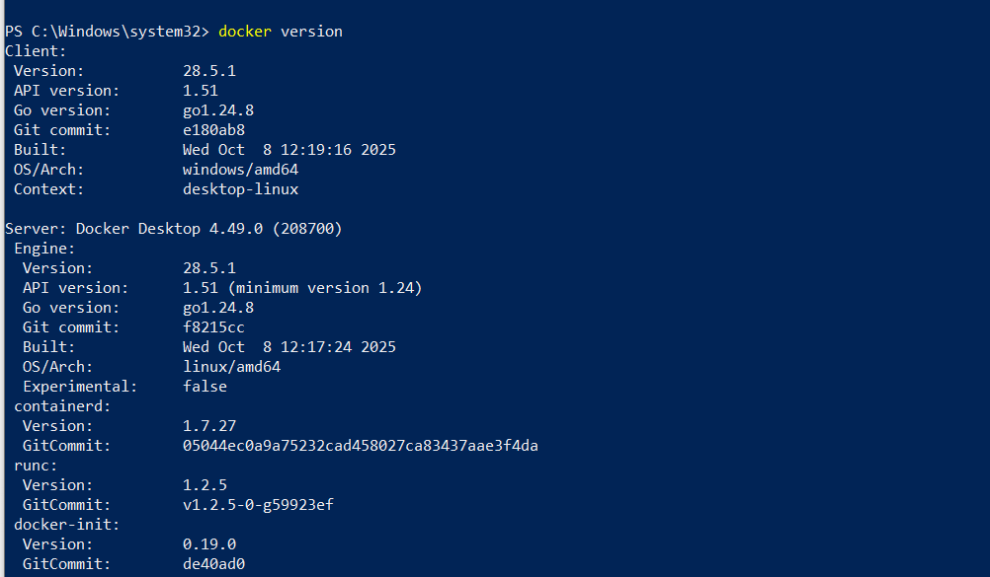

https://hub.docker.com/
Restart: Start-Service com.docker.service
docker info
docker version

Switch to windows
D:
mkdir docker-calculator
cd docker-calculator
Dockerfile (D:\docker-calculator\Dockerfile)
# Use Windows Server Core compatible with Windows 10 21H2
FROM mcr.microsoft.com/windows/servercore:20H2

# Install Python silently
RUN powershell -Command "Invoke-WebRequest -Uri https://www.python.org/ftp/python/3.12.0/python-3.12.0-amd64.exe -OutFile C:\python-installer.exe; Start-Process C:\python-installer.exe -ArgumentList '/quiet InstallAllUsers=1 PrependPath=1' -Wait; Remove-Item C:\python-installer.exe -Force"

# Default command to check Python version
CMD ["python", "--version"]

PS D:\docker-calculator> docker build -t docker37784/calculate:latest .

Step 3: Log in to Docker Hub
docker login
Step 4: Push the image to Docker Hub
docker push docker37784/calculate:latest
✅ After this, your image will be available at:
https://hub.docker.com/r/docker37784/calculate
>>>>>>>>>>>>>>>>>>>>>>>>>>>>>>>>>>>>>>>>>>>>>>.Again error:
PS D:\docker-calculator> docker system prune --all --force –volumes
PS D:\docker-calculator> docker system df
PS D:\docker-calculator> docker pull mcr.microsoft.com/windows/servercore:20H2

